2019 College & Career Readiness Champion Applications
ACT Council Support
Please copy/paste the content below to share with friends, colleagues, and your network to encourage applications for the 2019 ACT College and Career Readiness Champions Awards. This content should be shared between October 1 and October 31.
You are welcome to edit as you see fit.

E-Newsletter Content

Applications for the ACT College and Career Readiness Champion Awards are now open! This award program recognizes individuals’ exemplary efforts in advancing college and career readiness in four categories:
- Student Champion (student in the graduating class of 2019)
- K-12 Champion
- Postsecondary Champion
- Workforce Champion

Applications open October 1, 2018 and close October 31, 2018. One Champion per category will be selected in each state. All Champions receive individual certificates and recognition by the STATE ACT Council. Additionally, Student Champions receive a $500 non-renewable scholarship.

View the selection criteria and apply at www.act.org/readinesschampions. State Champions will be notified on or before January 31, 2019. Questions may be directed to ccrc@act.org.

Social Media – All 4 Categories
Click to tweet: .@ACT is recognizing high school seniors and #K12, #workforce, and #postseconday professionals who embody our mission. Apply before October 31: https://bit.ly/2N8FslE #ACTChampions #PSE #careerreadiness #collegereadiness #ACTStateOrgs

Click to tweet: Former ACT Workforce Champion Denny Smith helps #ACTStateOrgs kick off the application period for #ACTChampions with a new blog about the top 3 benefits to becoming a Champion: bit.ly/2OweZTw

Click to tweet: .@ACT is recognizing seniors who are tenacious and persistent and are prepared for life after high school with a goal in mind and a plan in place! Apply now, and you could earn a $500 #scholarship! 👉 https://bit.ly/2Oo0scO #ACTChampions #ACTStateOrgs

Facebook copy and paste: Applications for the 2019 ACT College and Career Readiness Champions have officially opened. Check out why you should nominate yourself or another exceptional individual to become a Champion for your state: https://bit.ly/2P3IeKr

LinkedIn copy and paste: Applications are open through October 31 for the 2019 ACT College & Career Readiness Champions Awards. Learn about how to recognize an individual making a positive impact through their efforts to advance college & career readiness: https://bit.ly/2Opp191

Graphics for Social Media:

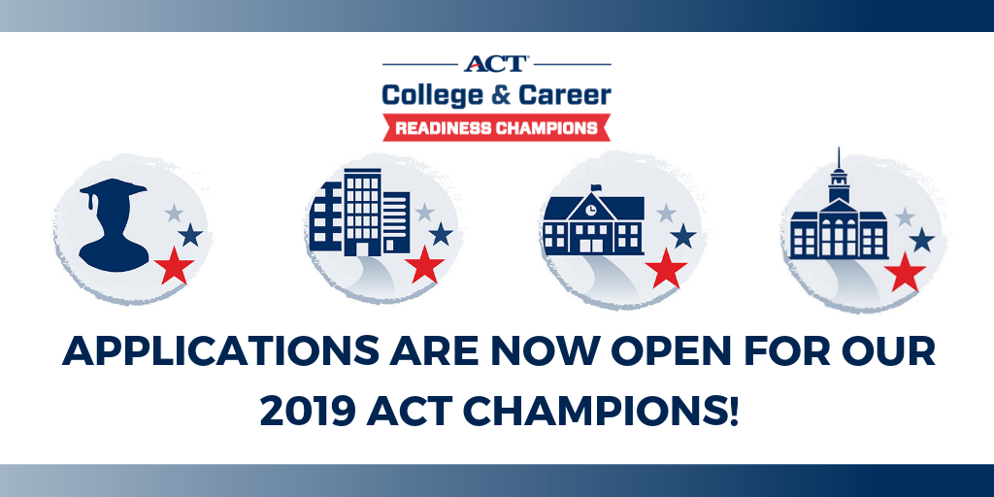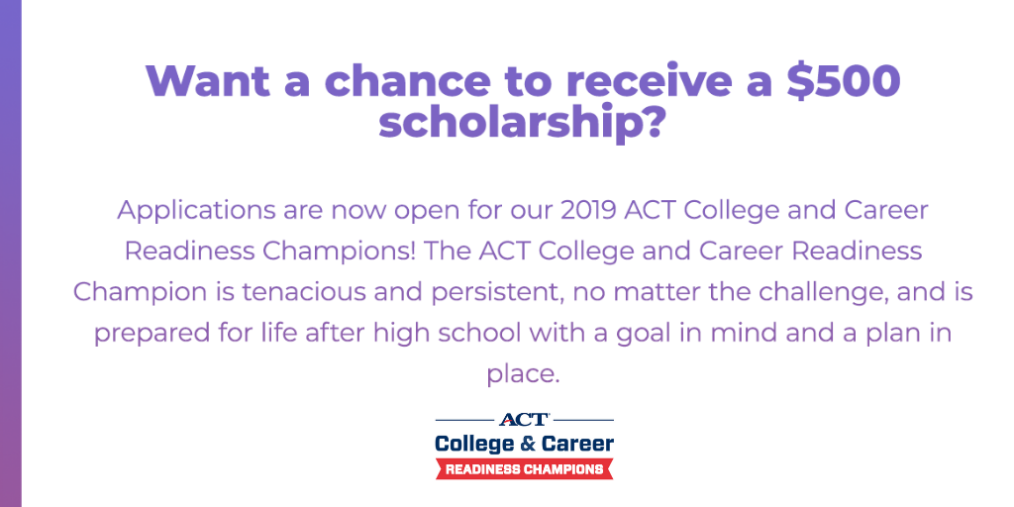

Personal/Mass Email Content – All 4 Categories

Subject line: Applications Now Open for STATE ACT College & Career Readiness Champion Awards

Greetings colleagues,

As you may know, I am a member of the STATE ACT Council. The STATE ACT Council serves as the Selection Committee for the STATE ACT College and Career Readiness Champions Awards.

Please take a few minutes to review this award program and consider sharing with high school seniors, making a nomination, or applying to be a Champion in the non-student categories.

ACT College and Career Readiness Champions are 1.) high school seniors; 2.) K-12 professionals; 3.) postsecondary professionals; and workforce professionals who are making a positive impact on their communities through their efforts to advance college and career readiness.

Applications open October 1, 2018 and close October 31, 2018. One Champion per category will be selected in each state. All Champions receive individual certificates and recognition by the STATE ACT Council. Additionally, Student Champions receive a $500 non-renewable scholarship.

View the selection criteria and apply at www.act.org/readinesschampions. Remember, applications close on October 31, 2018! State Champions will be notified on or before January 31, 2019. Questions may be directed to ccrc@act.org.

I would also encourage you to share this email with your colleagues and greater network.

Thank you,
YOUR NAME

Personal/Mass Email – Student Champion

Subject line: Applications Now Open for STATE ACT Student Champion

Greetings colleagues,

Applications are open for the ACT Student Champion Award! The ACT Student Champion Award recognizes one student in each state who is tenacious and persistent, no matter the challenge, and is prepared for life after high school with a goal in mind and plan in place.
ACT Student Champions receive a $500 non-renewable scholarship, certificate, and state-level recognition.

Please encourage students in the graduating class of 2019 who fit the following criteria to apply:
- High school seniors who have overcome challenges and can articulate their education and/or career actions
- At a minimum, students must have a composite ACT score of a 22 on a single test date OR a Gold ACT® WorkKeys® National Career Readiness Certificate®

Applications can be found at www.act.org/readinesschampions. Applications are due October 31, 2018, and Champions will be notified on or before January 31, 2019.

All questions may be directed to ccrc@act.org.

Best of luck!
YOUR NAME

Personal/Mass Email – Workforce Champion

Subject line: Applications Now Open for STATE ACT Workforce Champion

Greetings colleagues,

Applications are open for the ACT Workforce Champion Award! The ACT Workforce Champion is an individual who has created or led a program that positively impacts their company and community through improved hiring practices, apprenticeships/internships, or community leadership.

ACT Workforce Champions receive state-level recognition, and a certificate.

Please consider submitting your application for this award or nominating a colleague if the following criteria are met:
- Full-time employees in any role
- Individual’s program or initiative has included community partnerships (education institutions, chambers of commerce, Work Ready Community, etc.)

Applications can be found at www.act.org/readinesschampions. Applications are due October 31, 2018, and champions will be notified on or before January 31, 2019. Applications submitted by an individual participating in ACT Work Ready Communities may use this to meet recertification requirements.

All questions may be directed to ccrc@act.org.

Best of luck!
YOUR NAME

Personal/Mass Email – K-12 Champion

Subject line: Applications Now Open for STATE ACT K-12 Champion

Greetings colleagues,

Applications are open for the ACT K-12 Champion Award! The ACT K-12 Champion is an individual who has created or led a program that positively impacts their organization and community through improved readiness for college and career opportunities.

ACT K-12 Champions receive state-level recognition, and a certificate.

Please consider submitting your application for this award or nominating a colleague if the following criteria are met:
- Full-time employee at school or district in any role
- Individual’s program or initiative promotes college and career readiness
- Examples of potential applicants include teachers, counselors, support staff, principals, curriculum directors, intervention specialists, district administrators

Applications can be found at www.act.org/readinesschampions. Applications are due October 31, 2018, and champions will be notified on or before January 31, 2019.

All questions may be directed to ccrc@act.org.
Best of luck!
YOUR NAME

Personal/Mass Email – Postsecondary Champion

Subject line: Applications Now Open for STATE ACT Postsecondary Champion

Greetings colleagues,

Applications are open for the ACT Postsecondary Champion Award! The ACT Postsecondary Champion is a person who assists individuals in navigating their education and career journey.

ACT Postsecondary Champions receive state-level recognition, and a certificate.

Please consider submitting your application for this award or nominating a colleague if the following criteria are met:
- Full-time professional making a difference for learners in their role at a postsecondary/higher education institution
- Examples of potential applicants: individuals who work in recruitment, advising, education, retention, financial aid, placement, or other student services areas

Applications can be found at www.act.org/readinesschampions. Applications are due October 31, 2018, and champions will be notified on or before January 31, 2019.

All questions may be directed to ccrc@act.org.

Best of luck!
YOUR NAME

